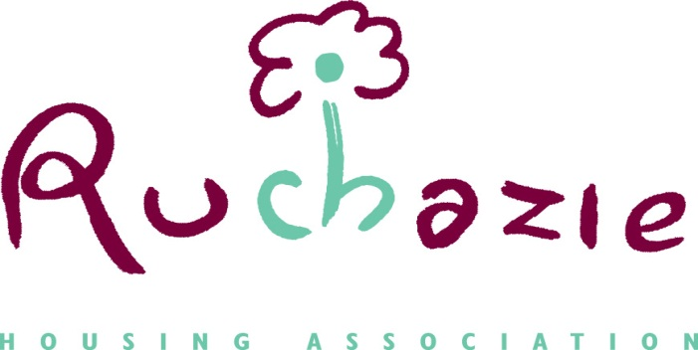

UNNACCEPTABLE ACTIONS POLICY

Date of Policy | March 2021
Date policy approved | March 2021
Date for review | March 2024

- Introduction
Ruchazie Housing Association ( RHA) aims to provide and excellent service to our tenants and those seeking a service from us. We aim to be open and accessible, and will listen to and respect those who wish to complain about our service. However, on rare occasions the behaviour or actions of complainants may make it difficult for us to respond to their complaints. When this happens we will consider the impact of the behaviour on our ability to do our work and provide a service to others. We believe that our employees have the right to be treated respectfully and where necessary we will take action to protect our staff.
- Purpose
We recognise that people may act out of character in times of trouble or distress. We also recognise that issues of health and disability may affect someone’s behaviour. However, we do consider actions that result in unreasonable demands on our staff or unreasonable behaviour towards staff to be unacceptable. This policy explains how we will approach these types of situation.

- Legislative and Regulatory Requirements
Scottish Social Housing Charter
The Scottish Social Housing Charter states what tenants can expect from social landlords, in terms of the quality and value for money of the services they receive, the standard of their homes, and opportunities for communication and participation in the decisions that affect them. This policy aims to ensure we meet the Charter standards and outcomes, in particular:

Outcome 1, Equality: Social landlords perform all aspects of their housing services so that every tenant and other customer has their individual needs recognised, is treated fairly and with respect, and receives fair access to housing and housing services.

Outcome 2, Communication: Social landlords manage their businesses so that tenants and other customers find it easy to communicate with their landlord and get the information they need about their landlord, how and why it makes decisions and the services it provides.

Standard 13, Value for Money: Tenants, owners and other customers receive services that provide continually improving value for the rent and other charges they pay.

- Equality and Diversity
We promote equality and diversity and operate equal opportunities policies which inform this policy and all aspects of our business. We will ensure that we meet the Equality Act 2010 by being committed to equal and fair treatment for all and opposed to any form of unlawful discrimination. In taking decisions about unacceptable actions, no one will be treated
differently or less favourably than others because of any of the protected characteristics as listed in the Equality Act 2010:

- age
- disability
- gender reassignment
- marriage and civil partnership
- pregnancy and maternity
- race
- religion or belief
- sex
- sexual orientation.
Upon request, we will make information about our Unacceptable Actions Policy and procedures available in alternative formats, such as large print, audio, Braille, and community languages.

- Model Complaints Handling Procedure

We have adopted the Model Complaints Handling Procedure for Registered Social Landlords produced by the Scottish Public Services Ombudsman (SPSO) in line with the Public Services Reform (Scotland) Act 2010. As part of this commitment, we use the policies and adopt the good practice available from the SPSO. The SPSO’s policy on Unacceptable Actions has been used to inform this policy.

- Definitions: Identifying unacceptable actions
We consider the following behaviour and actions described below to be unacceptable:
- Violent, aggressive or abusive behaviour

Violence is not restricted to acts of aggression that may result in physical harm. It also includes behaviour or language that may cause staff to feel offended, afraid, threatened or abused. Language which is designed to insult or degrade, which is racist, sexist or homophobic or which makes serious and

- unsubstantiated allegations of criminal, corrupt or perverse conduct is
unacceptable.
- Vexatious and persistent complaints or demands
Anyone accessing or complaining about our service has the right to pursue their concerns, and the right to complain if subsequent issues occur. Only in exceptional circumstances will we consider repeated complaining and persistent demands as unacceptable. This may include:
- Repeatedly demanding a response to a query or complaint within an unreasonable timescale
- Insisting on seeing or speaking to a particular member of staff when that is not possible.
- Repeatedly changing the substance of the original complaint or raising unrelated concerns
- Insisting that an adequate response has not been provided despite a full response having been given.

- Principles and Approach
Dealing with violent, aggressive or abusive behaviour
We will not accept violence or abuse towards our staff. If physical violence is used or threatened, we will report the incident to the Police. If a customer has used or threatened physical violence we may also consider restricting future contact with them to:
- written communication only
- personal contact by appointment only or in extreme cases having future contact through a named third party only.
- Where considered appropriate, we may make use of Acceptable Behaviour Contracts giving details of the behaviour expected and the consequences if the unacceptable behaviour continues.
- We will end telephone calls if the caller is aggressive, abusive or offensive. The staff member taking the call will have the right to make this decision, and will tell the caller that their behaviour is unacceptable and end the call if the behaviour persists.
- Dealing with vexatious and persistent complaints or demands
In cases where complaints or demands are vexatious and persistent, we will always try to take the minimum action required in order to solve the problem.
We will consider relevant personal circumstances including the seriousness of any complaint being made and any health issues or individual needs. Wherever possible, we will offer someone support or give someone the opportunity to change their behaviour before taking action. We will take such action as we consider appropriate and proportionate, such as:
- limiting contact to telephone calls at set times on set days
- restricting contact to a named member of staff who will deal with future calls or correspondence
- seeing the individual by appointment only.
Where we receive persistent, demanding letters, we will write to the individual to confirm that we will not answer future correspondence if there are no new issues of substance being reported.

- Appealing a decision
Anyone can appeal a decision taken under the terms of this policy. They may do so on the grounds that their actions were wrongly identified as unacceptable, the action taken was disproportionate, or that the action taken will adversely impact on them because of personal circumstances.
9. Roles and Responsibilities
All staff
All staff will be responsible for reporting any behaviour that causes them concern to the Senior Housing Services Officer. The decision that someone’s actions have been unacceptable under the terms of this policy will be taken by the Senior Housing Services Officer in conjunction another member of senior staff. The person will be informed of the decision and reasons in writing (and in any other form of communication as appropriate). They will be advised of the length of time for which any restrictions will be put in place, and the arrangements for reviewing any restrictions. We will also make clear to them that they can still request normal services from us (e.g. request a repair) while any restrictions are in place, and if necessary how they should go about doing that. They will also be informed that they can appeal the decision.

Director
Appeals will be considered by the Director who may decide to uphold the decision, quash the decision or vary the action to be taken based on the evidence available.
- Monitoring and Performance
If we make restrictions to how or when someone can contact us under the terms of this policy, we will review these periodically or on request. We will ensure that any restrictions are for set time periods only and that the person to which they apply is informed of the timescale and the date of review. We will report to the Board as part of our quarterly performance report, where restrictions have been placed on contact with an individual under the terms of this policy.
11. Customer Engagement and Consultation
We are committed to working with our tenants to improve the services we provide and to involve them in influencing decisions about their homes and their communities. We will consult with our tenants if we want to make changes to policies and service standards which will have a significant impact on them.
As part of this review, there are no significant changes to the Unacceptable Actions Policy and therefore we have signposted the policy on our website and newsletter for feedback and comment.
12. Confidentiality, data protection and rights of access
All information provided to us by individuals will be treated in strict confidence and will only be discussed with other parties with the individual’s (or their appointed representative’s) prior consent. We will comply with the Data Protection Act 1998 and the General Data Protection Regulations (EU) 2018 to make sure that personal information is kept secure and safe and our Privacy policy and customer leaflet ‘How we keep your information safe’ explain how and why we do this.
13. Policy review
This policy will be reviewed every 3 years unless key changes are required earlier to comply with legislation, guidance or new learning.

