Ruchazie Housing Association

Tenant Satisfaction Survey

June 2023

Prepared by: | Prepared for:
Research Resource | Ruchazie Housing Association
Contact: Lorna Shaw | Contact: Janice Shields
Tel: 0141 641 6410 | Tel: 0141 774 4433

Report written by: Rosemary Stafford

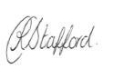
Date: 06/06/23

Reviewed by: Elaine MacKinnon / Lorna Shaw
Date: 07/06/23

Ruchazie Housing Association
Tenant Satisfaction Survey 2023
Contents

1. EXECUTIVE SUMMARY 5

2. INTRODUCTION, BACKGROUND AND OBJECTIVES 7
2.1 Introduction 7
2.2 Background and objectives 7
2.3 Research Method 7
2.4 Questionnaire design 8
2.5 Sample Size 8
2.6 Interviewing and Quality Control 9
2.7 Survey Analysis and Reporting 9

3. OVERALL SATISFACTION 11
3.1 Satisfaction with the overall service provided by Ruchazie (Q1) 11

4. INFORMATION 12
4.1 Communication sources (Q2/9) 12
4.2 Newsletter (Q3/4) 12
4.3 Keeping tenants informed (Q5/6) 13
4.4 Internet access (Q7/8) 14

5. PARTICIPATION 15
5.1 Involving residents in decision making opportunities (Q10-Q12) 15
5.2 Participation opportunities (Q13/14) 17

6. REPAIRS SERVICE 18
6.1 Satisfaction with the way Ruchazie deals with repairs and maintenance (Q15-Q17) 18

7. SATISFACTION WITH THE HOME 19
7.1 Quality of the home (Q18/19) 19
7.2 Priorities for maintenance (Q20) 20

8. RENT AND AFFORDABILITY 22
8.1 Value for money (Q21/22) 22
8.2 Housing Benefit (Q23) 23
8.3 Affordability of rent payments (Q24) 24
8.4 Affordability of fuel bills (Q25/26) 24
8.5 The welfare rights service and financial support (Q27-30) 25

9. THE NEIGHBOURHOOD 26
9.1 Neighbourhood as a place to live (Q31) 26
9.2 Satisfaction with aspects of the neighbourhood (Q32) 27
9.3 Satisfaction with landlord’s contribution to neighbourhood (Q33/34) 28

10. SERVICE PRIORITIES AND IMPROVEMENTS 29
10.1 Service priorities (Q35) 29
10.2 Service strengths (Q36) 30
10.3 Priorities for improvement (Q37) 30

11. YOU AND YOUR HOUSEHOLD 31
11.1 Household composition (Q39/40) 31
11.2 Age and gender (Q41/46/47) 31
11.3 Health conditions or disabilities (Q42/43) 32
11.4 Ethnicity (Q44) 32
11.5 Belief or religion (Q45) 32
11.6 Pregnancy/ maternity (Q48) 33
11.7 Sexual orientation (Q49) 33

12. CONCLUSIONS AND RECOMMENDATIONS 34

APPENDIX 1: QUESTIONNAIRE
APPENDIX 2: TECHNICAL REPORT SUMMARY

EXECUTIVE SUMMARY

INTRODUCTION
- Ruchazie Housing Association commissioned Research Resource to carry out a customer satisfaction survey on their behalf.
- A total of 142 interviews were carried out with Ruchazie Housing Association’s tenants in order to assess satisfaction with the Association and the services it provides. Interviews took place between the 29th of April and the 11th of May 2023.
- 142 interviews represents a 63% response rate from tenants in scope for the research.
- This executive summary highlights the key findings from this programme of research.

KEY CHARTER INDICATORS
Summarised below are the results for the key Scottish Social Housing Charter indicators for tenants relating to customer satisfaction. These have been compared to the Association’s previous survey which was carried out in 2020 and also to the Scottish Average for all social landlords as reported in the 2021/22 Annual Return on the Charter.
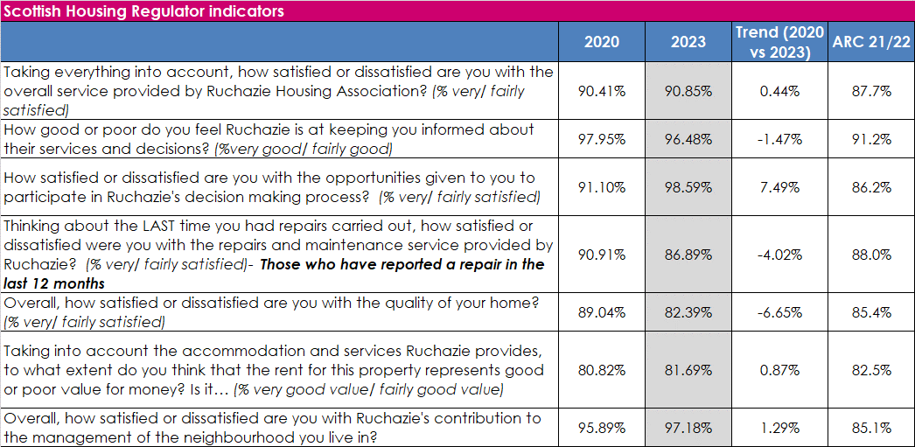

KEY POINTS
The results of the 2023 survey reveal that, in general, the Association is performing to a very high standard. The key findings from the survey are as follows:
- Overall satisfaction with the service provided by Ruchazie is high with 91% of tenants being very or fairly satisfied. Overall satisfaction has not seen a significant change since the last tenant satisfaction survey, undertaken in 2020 (90%).
- 96% of tenants said the Association was very or fairly good at keeping them informed about their services and decisions. Satisfaction has remained consistent since the 2020 survey where 98% rated the Association very or fairly good in this respect.
- 99% of tenants were very satisfied with the opportunities to participate in decision making processes, which has increased by 8 percentage points from 91% in the 2020 survey.
- 87% of respondents who have used the repairs service in the last 12 months said that they were satisfied with the repairs and maintenance service provided by Ruchazie, compared with the 2020 survey this is a decrease of 4 percentage points from 91%.
- 82% of tenants said they were very or fairly satisfied with the quality of their home. This is less than in the 2020 survey where 89% were very or fairly satisfied.
- Just over 8 in 10 participants (82%) said the rent for their accommodation and the services their landlord provides represents very or fairly good value for money compared to 9% who said it represented very or fairly poor value for money and 9% who said it was neither good nor poor value for money. The proportion stating their rent was good value for money is not significantly different than the 2020 result (81%).
- The majority of tenants (97%) were very or fairly satisfied with their landlord’s contribution to the management of the neighbourhood as a place to live. Satisfaction with the neighbourhood has seen no significant change compared to the 2020 survey where 96% were satisfied in this respect.

INTRODUCTION, BACKGROUND AND OBJECTIVES

Introduction
This report represents and discusses the findings to emerge from Ruchazie Housing Association’s Tenant Satisfaction Survey 2023.

Background and objectives
The aim of the research was to seek tenants’ views on the services that Ruchazie provides and how well it performs these services and to help identify areas where the service can be improved. Specifically, the research was designed to provide customers views on the following:
- The quality of information provided by Ruchazie
- Feedback on customer care;
- Quality of accommodation and the neighbourhood;
- Service provision including repairs, maintenance and improvements;
- Tenant involvement/ opportunities for participation;
- Value for money and affordability
It is against this background that Research Resource were commissioned to carry out Ruchazie Housing Association’s 2023 Tenant Satisfaction Survey.

Research Method
We note that the Ipsos MORI guidance prepared on behalf of the Regulator debates the use of a range of different methodologies for carrying out the survey, including postal, online, telephone and face to face survey methods. However, given the requirement for a minimum of a 40% response rate and ensuring representative samples of tenants, it was decided that the tenant survey was carried out using a mix of interviewer led methods with interviews carried out on a face-to-face basis. Our primary reasons for recommending this were:
- Administering the survey utilising an interviewer led methodology allows us to maximise the response rate.
- The proposed methodology is an inclusive methodology and allows interviewers to ensure that, for example, elderly or those with a disability or literacy problems can be included in the process. It also lets us identify any potential barriers to participation which can be raised and addressed in partnership with the Association.
- Facilitates high quality of survey output as it allows the interviewer to build up a rapport with the participant ensuring that the questionnaire is answered in full and allowing explanation of the necessity for asking personal data.

To maximise the response rate a small number of interviews (4) were completed by telephone.

Questionnaire design
After consultation with Ruchazie Housing Association’s representatives, a survey questionnaire was agreed which fully met the information needs and requirements of the organisation and included all issues of importance for tenants.

In developing the questionnaire the following issues were considered:
- The Scottish Social Housing Charter indicators upon which Ruchazie is required to report;
- Comparisons to the previous survey undertaken in 2020;
- Research Resource experience in relation to customer satisfaction surveying.

Sample Size
The aim of the survey was to achieve a robust level of data upon which the Association can have confidence making decisions upon and to maximise the response to the survey.
Overall, a total of 142 interviews were completed with Ruchazie tenants, representing a 63% response rate and providing data accurate to +5% based upon a 50% estimate at the 95% confidence level. Tenant interviews were spread across each area of the Association’s stock to ensure coverage of all stock types.
The guidance from the Scottish Housing Regulator states that in all surveys, particularly postal surveys, some groups are more likely than others to respond. This means that certain subgroups will be under-represented, and others will be over-represented in the final achieved sample (i.e. all the people who responded). Weighting ensures that received responses are representative of the whole survey population. The guidance suggests that social landlords will be likely to have suitable information on the population in terms of accommodation type (flats, semi detached house, detached, terraces) and the number of bedrooms.
The table below show the sample profile broken down by street and reveals that the interview profile has good coverage of all areas of the tenant population. The data reported is therefore unweighted.

 | No. of tenants | % of tenants | No. of interviews | % of interviews
Avondale Street | 29 | 12.8% | 18 | 12.7%
Balcomie Street | 26 | 11.5% | 16 | 11.3%
Bankend Street | 10 | 4.4% | 6 | 4.2%
Caprington Place | 16 | 7.0% | 10 | 7.0%
Claypotts Road | 44 | 19.4% | 28 | 19.7%
Craighouse Street | 22 | 9.7% | 14 | 9.9%
Drumlochy Road | 11 | 4.8% | 7 | 4.9%
Elibank Street | 38 | 16.7% | 22 | 15.5%
Gartcraig Road | 6 | 2.6% | 4 | 2.8%
Milncroft Place | 14 | 6.2% | 10 | 7.0%
Milncroft Road | 11 | 4.8% | 7 | 4.9%
Grand Total | 227 | 100.0% | 142 | 100.0%

Interviewing and Quality Control
All interviewing was undertaken by Research Resource’s highly trained and experienced field force, all of whom are highly experienced in undertaking customer satisfaction surveys for Housing Associations and Local Authorities.

Interviewing took place between the 29th of April and the 11th of May 2023.

Survey Analysis and Reporting
This report presents the findings of the survey for tenants and focuses on the key findings of the survey.

For the key Charter indicator responses, comparison has been drawn to Ruchazie’s previous tenant satisfaction survey which was completed in 2020. In drawing comparisons to these results it is worth noting the different methodology that was used, with interviews being carried out using a telephone methodology in 2020 compared to a face to face methodology in 2023.

Throughout this report the figures show the results as percentages and base numbers (the number of respondents to each question) are shown. Due to the small number of respondents, care should be taken when reading percentages.

Percentages are rounded up or down to one decimal place. Not all percentages will sum to 100% due to rounding. Rounding can also cause percentages described in the supporting text or summarising ‘overall satisfaction’ (i.e. adding very satisfied and fairly satisfied responses together) to differ from the charts by 1% when two percentages are added together.

Where respondents could select more than one response to a question the percentages will sum to more than 100%.

OVERALL SATISFACTION

Satisfaction with the overall service provided by Ruchazie (Q1)
The survey opened by asking tenants how satisfied or dissatisfied they were with the overall service provided by their landlord. The vast majority of tenants (91%) said they were very or fairly satisfied with the overall service the Association provides compared to 1% who said they were neither satisfied nor dissatisfied and 8% who were very or fairly dissatisfied. Overall satisfaction has not changed significantly compared to the 2020 tenant satisfaction survey where 90% were satisfied with the overall service provided by the Association.
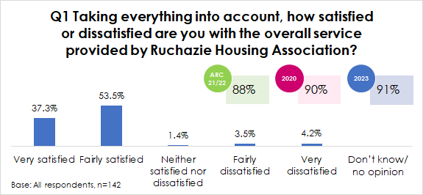

The tenants who were not satisfied with the overall service from Ruchazie, provided the following reasons for feeling that way. The main reasons given related to customer care or communication issues, regarding the repairs service or the quality of the home.
﻿

INFORMATION

Communication sources (Q2/9)
Respondents were asked which methods they would like Ruchazie to use to keep them up to date. Written communications were by far and away the most preferred methods of keeping up to date with 96% preferring to read the newsletter (62% in 2020) and 89% preferring to receive letters (69% in 2020). The results to this question did not vary significantly by age.

Q2 Which methods would you like to see Ruchazie using to keep you up to date at this time?
Base: All respondents, n=142 | No. | %
Newsletter | 136 | 95.8%
Letter | 126 | 88.7%
Telephone | 6 | 4.2%
Text | 3 | 2.1%
Facebook | 2 | 1.4%

Tenants were also asked about the method they would prefer to use to get in touch with the Association if they need to. Almost all tenants said they would prefer to use the telephone to contact the Association if they needed to get in touch. Analysis by age shows that tenants aged 16-34 (27%) and aged 35-44 (44%) were most likely to prefer email contact that tenants aged 55-64 (4%) or aged 65 and over (0%).

Q9 How would you prefer to get in touch with the Association if you need to?
Base: All respondents, n=142 | No. | %
Telephone | 140 | 98.6%
Email | 25 | 17.6%
Face to face at the office | 14 | 9.9%
Letter | 1 | 0.7%

Newsletter (Q3/4)
The majority of respondents (95%) read Ruchazie’s newsletter (95%, 90% in 2020). Just over a third of tenants (36%) would prefer to receive Ruchazie’s tenant news electronically such as through email or text. Analysis by age reveals that as age increases the proportion of respondents who would like to receive electronic news decreases. For example, from 77% for those aged 16-34 to 8% aged 55-64 and 0% of those aged 65 and over.

Keeping tenants informed (Q5/6)
All respondents were asked how good or poor they felt their landlord is at keeping tenants informed about their services and decisions. As shown below, the vast majority of tenants (96%) said they felt the Association was very or fairly good at keeping them informed, compared to 4% who said they were fairly poor in this respect.

The proportion of respondents stating that the Association is very or fairly good at keeping them informed has remained consistent compared to the 2020 survey (98%) and is higher than the Scottish average for all social landlords as reported in the ARC 2021/22.

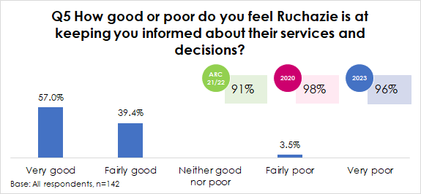

The tenants who were not satisfied were asked how Ruchazie could improve keeping them informed about services and decisions. Just five tenants stated were not satisfied in this respect and their comments are provided below:

- ﻿ Don't keep you updated on repairs.
- They don't tell you anything.
- Keep in touch - tell us what is happening.
- They need to be more transparent about what they are doing about giving us new kitchens.
- Sometimes the workmen just randomly turn up with no appointment.

Internet access (Q7/8)
Respondents were asked about internet access. The vast majority (82%) had access through their home broadband (73% in 2020) or had internet access via a mobile signal (82%, 77% in 2020).

Of those who had internet access, the vast majority would go online via a smartphone with mobile internet (92%, 64% in 2020).
Q8 How do you usually go online?
Base: Access the internet, n=119 | No. | %
A smartphone with mobile internet | 109 | 91.6%
A home computer/ laptop | 2 | 1.7%
A tablet device through which you can access the internet e.g. iPad | 8 | 6.7%

Analysis by age reveals that as age increases the proportion of tenants with internet access either home broadband or a mobile signal decreases. For example from 100% of tenants aged 16-34 who said they had internet access via a mobile signal to 52% of tenants aged 65 and over. .
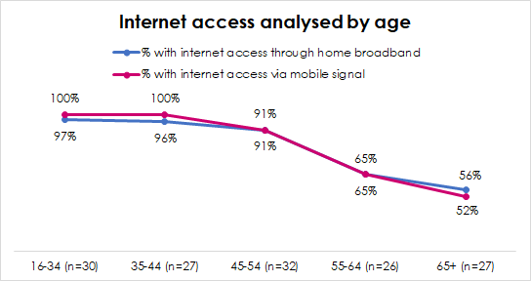

PARTICIPATION

Involving residents in decision making opportunities (Q10-Q12)
Respondents were asked if they were aware of various ways in which they could become involved in its decision-making processes, and then asked if they were interested in these.

As shown below, awareness was highest for becoming a committee member of the Association (77%, 65% in 2020) and providing views in surveys (35%, 62% in 2020). Just under one in five respondents (18%, 19% in 2020) said they were not aware of any of these ways in which they could get involved.

In terms of interest, the vast majority were not interested in taking part in any of the various activities (70%, 72% in 2020). Where tenants were interested this tended to be by providing their views in surveys (28%).

Q10 Are you aware that you could be involved in any of the following ways? / Would you be interested in becoming more involved in any of these ways?
 | Q10a % aware |  | Q10b % interested
Base: All respondents, n=142 | No. | % | No. | %
By receiving regular information about the Association’s decisions and activities | 10 | 7.0% | 3 | 2.1%
By providing your views in surveys like this | 49 | 34.5% | 40 | 28.2%
Being part of the Association’s register of interested tenants – a list of tenants who want to be consulted on Association policies | 18 | 12.7% | 1 | 0.7%
By taking part in consultation exercises on specific issues e.g. through attending public meetings | 33 | 23.2% | - | -
Participating in occasional focus groups | 9 | 6.3% | - | -
Becoming a Committee Member of the Association | 109 | 76.8% | - | -
Not aware of/ interested in any of the above | 25 | 17.6% | 100 | 70.4%

Respondents were then asked what, if anything stops them becoming more involved with the Association. The most common answers were:
- Childcare commitments (28%)
- Happy with things as they are (25%)
- Not interested (19%)
- Health/ disability issues (18%)
Q12 What, if anything, stops you becoming more involved with Ruchazie Housing Association?
Base: All respondents, n=142 | No. | %
Childcare commitments | 39 | 27.5%
Happy with things as they are | 36 | 25.4%
Not interested | 27 | 19.0%
Health / disability issues | 26 | 18.3%
Work commitments | 22 | 15.5%
Don’t think I have anything to contribute | 14 | 9.9%
Don’t think they listen anyway | 5 | 3.5%
Lack confidence in speaking up | 2 | 1.4%
Don’t understand enough about the work of the Association | 2 | 1.4%
Other | 3 | 2.1%
Nothing, I am already involved | 4 | 2.8%

Participation opportunities (Q13/14)
Tenants were then asked how satisfied or dissatisfied they were with the opportunities given to them to participate in their landlords’ decision making opportunities. As shown below, 99% were very or fairly satisfied with the participation opportunities. The proportion of respondents stating they were satisfied in this respect has increased by 8 percentage points since the 2020 survey (91%).

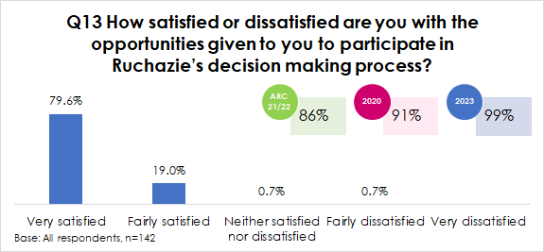

Respondents who were not satisfied were asked how Ruchazie could improve the opportunities given to you to participate in their decision-making processes. The two tenants provided the following comments:
- Never hear anything.
- They never sorted my kitchen to a decent standard - it looks a mess.

REPAIRS SERVICE

Satisfaction with the way Ruchazie deals with repairs and maintenance (Q15-Q17)
Just over 4 in 10 respondents (43%) stated they had a repair carried out in the last year.

When asked about their satisfaction with the last repair they had carried out, 87% said that they were satisfied with the repairs and maintenance service provided by Ruchazie, compared with 8% who were neither satisfied nor dissatisfied and 5% who were dissatisfied. Compared to the 2020 survey satisfaction has decreased by 4 percentage points from 91%. Overall satisfaction is in line with the Scottish average for all social landlords reported in the 2021/22 ARC.
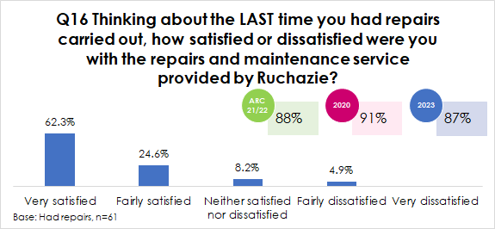

The majority of respondents said there was nothing (62%) that could be done to improve the repairs service or that they were happy with the repairs service. On the other hand, 13% spoke about poor quality repairs and 10% mentioned repairs taking too long to complete.
Q17 What, if anything, could have been done to improve the repairs process?
Base: Not satisfied with repairs service, n=61 | No. | %
Nothing/ happy with repairs | 38 | 62.3%
Poor quality repairs | 8 | 13.1%
Repairs take too long to complete | 6 | 9.8%
Don't know/ no comment | 5 | 8.2%
Improvements needed to communication/ customer service | 4 | 6.6%
Other | 2 | 3.3%

SATISFACTION WITH THE HOME

Quality of the home (Q18/19)
With regards to the quality of the home, the majority of participants (82%) said they were very or fairly satisfied with the quality of their home compared to 10% who were dissatisfied and 11% who were neither satisfied nor dissatisfied. The proportion of respondents who said they were satisfied in this respect has decreased by 7 percentage points since the 2020 survey and is slightly lower than the Scottish average reported in the 2021/2 ARC (85%).
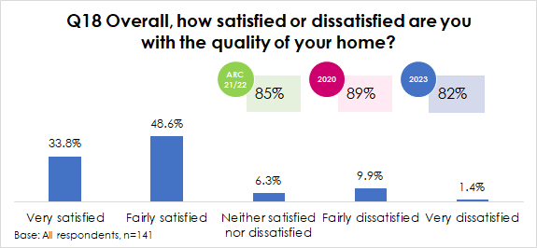

Those who were not satisfied (25 respondents) were asked to provide details of why they felt this way. This tended to be where respondents spoke about upgrades that were needed to their home such as new windows, kitchens or bathrooms or outstanding repairs issues that were needed to be fixed in their home.

Analysis shows that some streets were much more likely to be satisfied with the quality of their home than others, although please be aware that due to the very small numbers this analysis is not statistically robust.
Quality of the home analysed by area
 | Base | % very/ fairly satisfied | % neither satisfied nor dissatisfied | % very/ fairly dissatisfied
Gartcraig Road | 4 | 100% | - | -
Milncroft Place | 10 | 100% | - | -
Milncroft Road | 7 | 100% | - | -
Claypotts Road | 28 | 89% | 11% | -
Balcomie Street | 16 | 88% | 13% | -
Craighouse Street | 14 | 86% | 14% | -
Elibank Street | 22 | 86% | 9% | 5%
Bankend Street | 6 | 83% | - | 17%
Ruchazie HA | 142 | 82% | 6% | 11%
Avondale Street | 18 | 78% | - | 22%
Drumlochy Road | 7 | 43% | - | 57%
Caprington Place | 10 | 40% | - | 60%

Priorities for maintenance (Q20)
Respondents were then asked what they regarded as being the top 3 priorities for maintenance in their home. The table below shows the overall priority value, i.e. the sum of tenants rating each aspect a top, second or third priority.
- Window replacement (48%)
- Bathroom upgrade/ replacement (34%)
- Kitchen upgrade/ replacement (34%)
These were also the top three priorities identified in the 2020 survey.
Q20 Ruchazie has a planned maintenance programme in place. What do you regard as being the top three priorities for maintenance in your home? (% overall priority)
Base: Not satisfied with repairs service, n=61 | No. | %
Window replacement | 68 | 48.0%
Bathroom upgrade/ replacement | 48 | 34.0%
Kitchen upgrade/ replacement | 48 | 34.0%
New external doors | 34 | 24.0%
Measures to deal with dampness/ condensation | 9 | 6.0%
Insulation against heat loss/ draught proofing | 7 | 5.0%
Other (please specify) | 6 | 4.0%
Energy efficiency measures to make your home warmer and easier to heat | 5 | 4.0%
Rewiring | 0 | 0.0%
No priorities | 27 | 19.0%

Further analysis by street revealed that respondents from Avondale Street, Balcomie Street, Gartcraig Road and Claypotts Road were most likely to list window replacement as being their top priority for improvement in their home. On the other hand tenants living in Craighouse Street, Drumlochy Road, Milncroft Place, Caprington Place and Elibank Street were most likely to say an upgraded kitchen was their top priority.
Top priority for the home analysed by street
 | Craighouse Street | Avondale Street | Balcomie Street | Gartcraig Road | Drumlochy Road | Bankend Street | Milncroft Place | Caprington Place | Claypotts Road | Elibank Street | Milncroft Road
Base | 14 | 18 | 16 | 4 | 7 | 6 | 10 | 10 | 28 | 22 | 7
Window replacement | 7% | 78% | 88% | 50% | - | - | 10% | - | 57% | 9% | -
Rewiring | - | - | - | - | - | - | - | - | - | - | -
Bathroom upgrade/ replacement | 14% | 11% | 6% | 25% | - | - | - | 20% | 14% | 9% | 14%
Kitchen upgrade/ replacement | 29% | - | - | - | 86% | 17% | 70% | 30% | 4% | 50% | 14%
New external doors | 7% | 6% | - | - | - | 17% | - | 10% | 4% | 9% | -
Insulation against heat loss/ draught proofing | - | - | - | - | - | - | - | - | 4% | - | -
Measures to deal with dampness/ condensation | - | - | - | - | - | - | - | 10% | 4% | - | -
Other | - | - | - | - | - | 17% | - | - | - | 18% | 14%
No priorities | 43% | 6% | 6% | 25% | 14% | 50% | 20% | 30% | 14% | 5% | 57%

RENT AND AFFORDABILITY

Value for money (Q21/22)
Just over 8 in ten respondents (82%) said the rent for their accommodation and the services their landlord provides represents very or fairly good value for money compared to 9% who said it represented very or fairly poor value for money and 9% who said it was neither good nor poor value for money.

The proportion stating their rent was good value for money has decreased by 4 percentage points from 91% in 2020. However, overall satisfaction is in line with the Scottish average reported in the 2021/22 ARC (88%).
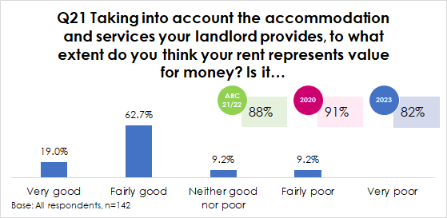

All respondents were then asked to provide comments for feeling this way about the value for money for their rent. The open ended comments were grouped into common themes and are displayed in the table below. Positive comments about rents were where tenants were happy with their rent and thought it was a fair price (26%), that it was cheaper, or fair compared to other housing options (12%) and that it was good value for the area or the size or quality of the home (6%).

Where respondents were negative about the value for money of rents this tended to be where they felt the rent charge was too expensive (11%), where they mentioned frequent rent increases (17%) or where they felt their rent did not reflect the quality of their home and their property required upgrades (2%).

Q22 Can you explain why you say that?
Base: All respondents | No. | %
I get mine paid with benefits | 47 | 33.1%
Happy with it/ fair price | 37 | 26.1%
Cheaper/ fair compared to other places/ private landlord | 17 | 12.0%
Good value for area/ size/ quality of home | 8 | 5.6%
Too expensive | 15 | 10.6%
Increases every year | 24 | 16.9%
Needs upgrades | 3 | 2.1%
Don't know/ No comment | 6 | 4.2%

Housing Benefit (Q23)
In terms of housing benefit, just under 4 respondents (37%) said they were in receipt of full housing benefit, 12% were in receipt of partial housing benefit and 12% said they received universal credit. 39% of respondents pay full rent.
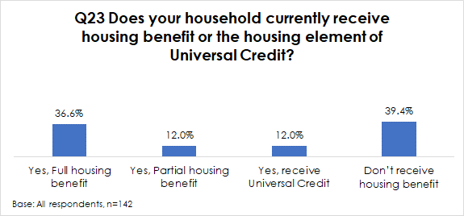

Analysis of value for money of rent by receipt of housing benefit/ universal credit reveals that those who paid full rent (64%) were less likely to say their rent was good value for money (64%) than those who were in receipt of full housing benefit (94%), partial housing benefit (88%) or received Universal Credit (94%).

Affordability of rent payments (Q24)
Participants who paid their rent, or part of their rent were asked how easy or difficult they found it to afford the rent payments for their home. As shown below, 37% of respondents said they find their rent payments very or fairly easy to afford and 56% said it is just about affordable. Only 8% of tenants said their rent was difficult to afford. The proportion of respondents who said their rent is easy to afford has decreased from 44% in 2020 to 37% in 2023. None of the 17 tenants who received Universal Credit said their rent was easy to afford, all said it was just about affordable. Tenants who received partial housing benefit (12%) or paid full rent (9%) were most likely to say their rent was difficult to afford.
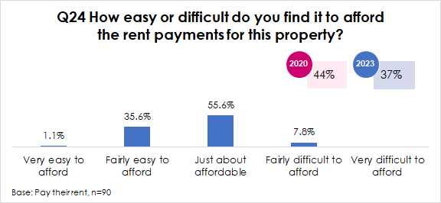

Affordability of fuel bills (Q25/26)
Over 6 in 10 tenants (61%) said their electricity and gas bills were just about affordable. More tenants were of the opinion that their bills were difficult to afford (27%) than easy to afford (11%).
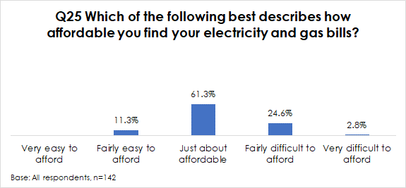

Over 6 in 10 tenants said that in the last year they had chosen to not put their heating on because they could not afford it (62%). Tenants aged 35-44 (78%) were most likely to have not put their heating on due to affordability issues, while tenants aged 65 and over were least likely to say they have done this (44%).

The welfare rights service and financial support (Q27-30)
Two thirds of tenants (66%) were aware that the Association has a Welfare Rights Service.

The vast majority (78%) were aware that Ruchazie has received funds to help tenants with the cost of living crisis. For example, support to help with paying fuel bills food vouchers and clothing etc. Three in four tenants said they have received support from Ruchazie to assist with the cost of living crisis, amounting to 106 tenants.

A total of 14 tenants provided suggestions for things that Ruchazie could be doing to help tenants with the cost of living crisis. Their suggestions are listed below and include providing more shopping vouchers and providing more information to tenants on the help and support that is available.
- Give more shopping vouchers when they can.
- Give more shopping vouchers when they can.
- Tell tenants what help there is available for them.
- If they told us what was available for help.
- Tell people what they have available - I did not know this.
- Tell their tenants what help they have available - I did not know.
- Tell people what is available to them.
- Tell everyone what they have available.
- More shopping vouchers.
- Tell people what they have available in a text or email.
- Encourage more shopping vouchers.
- Maybe more help with fuel, although they have been very good.
- Remember the tenants that are working full time and pay full rent. We struggle like everyone else, but we don't get the help.
- Upgrade the properties.

THE NEIGHBOURHOOD

Neighbourhood as a place to live (Q31)
In terms of the neighbourhood as a place to live, almost all tenants (97%) said they were very or fairly satisfied with their neighbourhood compared to 1% who were neither satisfied nor dissatisfied and 2% who were very dissatisfied.
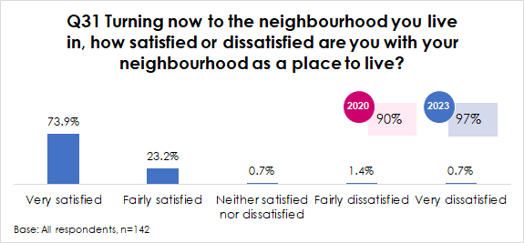

Satisfaction with the neighbourhood as a place to live analysed at street level is shown in the table below. As can be seen below, only tenants living in Drumlochy Road (2 tenants) and in Caprington Place (1 tenant) were dissatisfied with their neighbourhood as a place to live.
Neighbourhood as a place to live analysed by area
 | Base | % very/ fairly satisfied | % neither satisfied nor dissatisfied | % very/ fairly dissatisfied
Claypotts Road | 28 | 100% | - | -
Avondale Street | 18 | 100% | - | -
Balcomie Street | 16 | 100% | - | -
Craighouse Street | 14 | 100% | - | -
Milncroft Place | 10 | 100% | - | -
Milncroft Road | 7 | 100% | - | -
Bankend Street | 6 | 100% | - | -
Gartcraig Road | 4 | 100% | - | -
Ruchazie HA | 142 | 97% | 1% | 2%
Elibank Street | 22 | 95% | 5% | -
Caprington Place | 10 | 90% | - | 10%
Drumlochy Road | 7 | 71% | - | 29%

Satisfaction with aspects of the neighbourhood (Q32)
As shown below satisfaction levels varied, ranging from 69% in terms of close cleaning (82% in 2020), to 94% in terms of grounds maintenance (97% in 2020) and 95% with regards to the contractor who carried out the ground maintenance (86% in 2020).
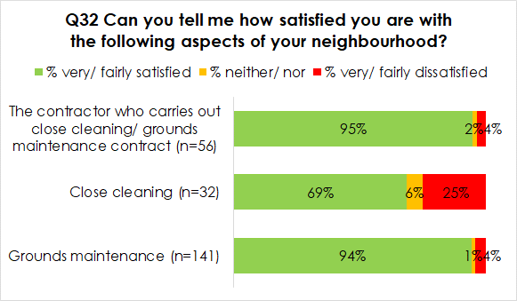

Following on from this, tenants were asked to provide any follow up comments on the neighbourhood aspects. The majority (63%) had no further comments and 17% said they were happy with the maintenance of the area. On the other hand, 9% would like to see better cleaning of closes or maintenance of communal areas and 6% commented on issues with bins, rubbish and fly tipping.

Q32 Do you have any comments you would like to make?
Base: All respondents, n=142 | No. | %
No comment/ Nothing | 90 | 63.4%
Happy with area/ well maintained | 24 | 16.9%
Better cleaning of close/ maintenance of communal areas | 12 | 8.5%
Bins, rubbish, fly tipping issues | 8 | 5.6%
Trim trees/ cut grass | 5 | 3.5%
Fences need repaired/ replaced | 2 | 1.4%
Other | 4 | 2.8%

Satisfaction with landlord’s contribution to neighbourhood (Q33/34)
Respondents were asked how satisfied they were with the landlord’s contribution to the neighbourhood they live in. The majority of tenants (97%) were very or fairly satisfied compared to 3% who were very or fairly dissatisfied.

Satisfaction compared with 2020 has seen no significant change with 96% being satisfied with the Association’s contribution to the management of the neighbourhood in 2020. Satisfaction is considerably higher than the Scottish average reported in the 2021/22 Annual Return on the Charter for all Scottish social landlords (85%).
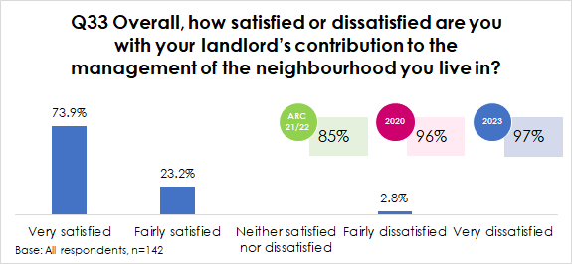

The four tenants who were not satisfied in this respect provided the following suggestions as to how the Association could improve in this respect:
- Close doesn't get cleaned.
- They could tidy it up better.
- They could do more about the rubbish problem, makes the place look not nice.
- They should clear up the area at old school and put CCTV up. Also the green bins are getting stolen, and you have to pay for new ones - CCTV would help that too.

SERVICE PRIORITIES AND IMPROVEMENTS

Service priorities (Q35)
Respondents were then asked to list what would be their top three priorities for services. As shown below, the most popular priorities chosen were:
- A good quality repairs service (87% selecting as a top, second or third priority)
- Charge affordable rents (66%)
- Improve homes (55%)

Q35 Which of the following services would you consider to be your top three priorities of the following list:
Base: All respondents, n=142 | No. | %
Good quality repairs service | 123 | 87.0%
Charge affordable rents | 94 | 66.0%
Improve homes | 78 | 55.0%
Providing good customer service | 58 | 41.0%
Managing the environment around your home | 22 | 15.0%
Good quality landscape maintenance (e.g. grass cutting, weeding etc) | 14 | 10.0%
Support for tenants | 10 | 7.0%
Rent arrears assistance | 3 | 2.0%
No priorities | 3 | 2.0%
Giving energy advice | 0 | 0.0%
Tenant involvement in developing policies | 0 | 0.0%

In 2020, the top priority has remained consistent with a good quality repairs service being most important to tenants (82%). However, the current financial crisis is reflected in tenants’ priorities for services and has increased from 4th priority in 2020 (34%) to second priority in 2023 (66%)

Service strengths (Q36)
Respondents were asked to state what they think the Association do best. The open ended comments given were grouped into common themes and are displayed in the table below. The most common strengths listed were:
- Repairs (20%)
- Gave us vouchers to help with crisis/ there if we need them (14%)
- Good customer service / prompt(7%)
Q36 Thinking about the overall service provided by Ruchazie Housing Association, what do you think they do best?
Base: All respondents, n=142 | No. | %
Don't know/ no complaints | 47 | 33.1%
Overall good - no specifics | 31 | 21.8%
Repairs are good/ quick | 28 | 19.7%
Gave us vouchers to help with crisis/ there if we need them | 20 | 14.1%
Good customer service/ prompt response | 10 | 7.0%
Nothing/ unhappy with HA | 6 | 4.2%
Good communication | 5 | 3.5%
Keep the area clean/ well maintained | 2 | 1.4%
Happy with upgrade | 1 | 0.7%

Priorities for improvement (Q37)
Respondents were then asked if there was one thing that the Association could do to improve their overall service. The comments provided were grouped into common themes and are displayed in the table below. Encouragingly, the most common response was where tenants were unable to provide a suggestion or said they were happy with everything (30%). The most common suggestions for improvement were:
- Upgrades/ improvements to homes (23%)
- Better communication/ follow up/ listen to tenants (11%)
- Clean area/ deal with rubbish/ close cleaning (5%)
Q37 And if there was one thing that Ruchazie Housing Association could do to improve their overall service, what would it be?
Base: All respondents, n=142 | No. | %
Nothing/ happy with everything | 42 | 29.6%
Upgrades required e.g. kitchen, bathroom, windows, doors etc | 34 | 23.9%
Better communication/ follow ups/ listen to tenants | 16 | 11.3%
Clean area/ rubbish problem/ close cleaning | 7 | 4.9%
More help with financial crisis/ cheaper rents | 5 | 3.5%
Trim trees/ cut grass | 3 | 2.1%
Quicker repairs service | 2 | 1.4%
Other | 6 | 4.2%
Don't know/ No comment | 35 | 24.6%

YOU AND YOUR HOUSEHOLD

Household composition (Q39/40)
In terms of household composition, a quarter of tenants (25%) were single adult households, 23% were two adults with no children, 24% were lone parents with at least one child, 23% were couples with at least one child, and 4% were three or more adults.

Q40 How would you describe the composition of your household?
Base: All respondents, n=142 | No. | %
Single adult | 36 | 25.4%
Two adults | 33 | 23.2%
Three or more adults, 16 or over | 5 | 3.5%
1 parent family | 34 | 23.9%
2 parent family | 32 | 22.5%
Other | 2 | 1.4%

Age and gender (Q41/46/47)
The majority of respondents were female (73%) 27% were male. No respondents considered themselves to be a trans person.

With regards to the age profile of participants, 21% were aged 16 to 34, 19% were aged 35 to 44, 23% were aged 45-54, 18% were aged 55-64 and 19% were aged 65 and over.
Q41 What is your age group?
Base: All respondents, n=142 | No. | %
16-24 | 2 | 1.4%
25-34 | 28 | 19.7%
35-44 | 27 | 19.0%
45-54 | 32 | 22.5%
55-64 | 26 | 18.3%
65-74 | 21 | 14.8%
75-84 | 6 | 4.2%

Health conditions or disabilities (Q42/43)
Just over a third of respondents (34%) said that either they or a member of their household had a disability. This was most likely to be regarding a physical impairment (52%).

Q43 How would you describe the nature of your disability from the following list?
Base: All respondents, n=142 | No. | %
Autoimmune: (e.g. multiple sclerosis, HIV, Crohn’s/ulcerative colitis) | 6 | 12.5%
Learning difficulties: (e.g. Down’s Syndrome) | 1 | 2.1%
Mental health issue: (e.g. depression, bi-polar) | 8 | 16.7%
Neuro-divergent condition: (e.g. autistic spectrum, Dyslexia, dyspraxia) | 1 | 2.1%
Physical impairment: (e.g. wheelchair-user, cerebral palsy) | 25 | 52.1%
Hearing impairment) | - | -
Visual impairment | - | -
Other (please specify) | 10 | 20.8%
Prefer not to say | 5 | 10.4%

Ethnicity (Q44)
With regards to ethnicity, the vast majority said they were White Scottish or White British (92%).

Q44 What is your ethnic group?
Base: All respondents, n=142 | No. | %
Scottish | 130 | 91.5%
Other British | 1 | 0.7%
Polish | 6 | 4.2%
Roma | 1 | 0.7%
African, Scottish African or British African | 2 | 1.4%
Other, please write in | 2 | 1.4%

Belief or religion (Q45)
The majority of tenants had no specific religion or belief (85%), 10% were catholic, 4% were other Christian and 1% were protestant.
Q45 What best describes your belief or religion?
Base: All respondents, n=142 | No. | %
No specific religion or belief | 120 | 84.5%
Catholic | 14 | 9.9%
Other Christian | 6 | 4.2%
Protestant | 2 | 1.4%

Pregnancy/ maternity (Q48)
No respondents said they were pregnant and just one respondent said they had taken maternity or paternity leave in the past year.

Sexual orientation (Q49)
All respondents said their sexual orientation was heterosexual or straight.

CONCLUSIONS AND RECOMMENDATIONS

This survey represents a very positive survey for Ruchazie Housing Association. Throughout the report and where comparisons are available it is clear that satisfaction levels have in general remained high compared to the 2020 survey results.

KEY POINTS
The results of the 2023 survey reveal that, in general, the Association is performing to a very high standard. The key findings from the survey are as follows:
- Overall satisfaction with the service provided by Ruchazie is high with 91% of tenants being very or fairly satisfied. Overall satisfaction has not seen a significant change since the last tenant satisfaction survey, undertaken in 2020 (90%).
- 96% of tenants said the Association was very or fairly good at keeping them informed about their services and decisions. Satisfaction has remained consistent since the 2020 survey where 98% rated the Association very or fairly good in this respect.
- 99% of tenants were very satisfied with the opportunities to participate in decision making processes, which has increased by 8 percentage points from 91% in the 2020 survey.
- 87% of respondents who have used the repairs service in the last 12 months said that they were satisfied with the repairs and maintenance service provided by Ruchazie, compared with the 2020 survey this is a decrease of 4 percentage points from 91%.
- 82% of tenants said they were very or fairly satisfied with the quality of their home. This is less than in the 2020 survey where 89% were very or fairly satisfied.
- Just over 8 in 10 participants (82%) said the rent for their accommodation and the services their landlord provides represents very or fairly good value for money compared to 9% who said it represented very or fairly poor value for money and 9% who said it was neither good nor poor value for money. The proportion stating their rent was good value for money is not significantly different than the 2020 result (81%).
- The majority of tenants (97%) were very or fairly satisfied with their landlord’s contribution to the management of the neighbourhood as a place to live. Satisfaction with the neighbourhood has seen no significant change compared to the 2020 survey where 96% were satisfied in this respect.

Appendix 1
Survey Questionnaire

OVERALL SATISFACTION
- [SSHC] Taking everything into account, how satisfied or dissatisfied are you with the overall service provided by Ruchazie Housing Association?
Very satisfied | 1 | Go to Q2
Fairly satisfied | 2
Neither satisfied nor dissatisfied | 3 | Go to Q1b
Fairly dissatisfied | 4
Very dissatisfied | 5
Don’t know/ no opinion | 6 | Go to Q2
Q1b [IF NOT SATISFIED: CODE 3,4,5] Can you explain why you are not satisfied with the overall service provided?

INFORMATION AND COMMUNICATION
- Ruchazie use a range of different methods to keep their tenants informed. Which methods would you like to see Ruchazie using to keep you up to date at this time? [ALL THAT APPLY]
Website | 1 | Go to Q3
Facebook | 2
Newsletter | 3
Letter | 4
Text | 5
Telephone | 6
Other (please specify) | 7

- Do you read Ruchazie’s tenant newsletter?
Yes | 1 | Go to Q4
No | 2

- Would you prefer to receive Ruchazie’s tenant news electronically such as through email or text?
Yes | 1 | Go to Q5
No | 2

- [SSHC] How good or poor do you feel Ruchazie is at keeping you informed about their services and decisions?
Very good | 1 | Go to Q7
Fairly good | 2
Neither good nor poor | 3 | Go to Q6
Fairly poor | 4
Very poor | 5

- How could Ruchazie improve how they keep you informed about their services and decisions?

- I’d now like to ask you about access to the internet?
 | Yes | No
Do you have access to the internet in your home through home broadband? | 1 | 2
Do you have access to the internet through a mobile signal e.g. smartphone or tablet with mobile internet access? | 1 | 2
IF NO TO BOTH GO TO Q9

- How do you usually go online? SELECT ONE ONLY
A smartphone with mobile internet | 1 | Go to Q9
A home computer/ laptop | 2
A tablet device through which you can access the internet e.g. iPad | 3
Through any other methods (please describe) | 4
Do not use the internet | 5

- How would you prefer to get in touch with the Association if you need to?
Email | 1 | Go to Q10
Telephone | 2
Text / SMS | 3
What’s App | 4
Facebook | 5
Letter | 6
Face to face at the office | 7
Video call | 8
Other - please state | 9

PARTICIPATION
- The Association undertakes a number of activities to involve residents in its decision making processes. A) are you aware that you could be involved in any of the following ways? B) would you be interested in becoming more involved in any of these ways?
 | A) Aware | B) interested
By receiving regular information about the Association’s decisions and activities | 1 | 1
By providing your views in surveys like this | 2 | 2
Being part of the Association’s register of interested tenants – a list of tenants who want to be consulted on Association policies | 3 | 3
By taking part in consultation exercises on specific issues e.g. through attending public meetings | 4 | 4
Participating in occasional focus groups | 5 | 5
Becoming a Committee Member of the Association | 6 | 6
Not interested in participating in any of the above |  | 7
Not aware of any of the above | 7

- [IF Q10B=(1~6)] If interested in becoming involved, are you happy that we pass your name and address to the Association so that they can provide you with more information? All your other responses will remain completely confidential and anonymous.
Yes | 1
No | 2

- What, if anything, stops you becoming more involved with Ruchazie Housing Association? [INTERVIEWER: DO NOT PROMPT]
Childcare commitments | 1
Work commitments | 2
Health / disability issues | 3
Not interested | 4
Don’t think I have anything to contribute | 5
Lack confidence in speaking up | 6
Don’t understand enough about the work of the Association | 7
Not aware of any meetings/ opportunities to participate | 8
Don’t think they listen anyway | 9
Happy with things as they are | 10
Other – please specify | 11
Nothing, I am already involved | 12

- [SSHC] How satisfied or dissatisfied are you with the opportunities given to you to participate in Ruchazie’s decision making process?
Very satisfied | 1 | Go to Q15
Fairly satisfied | 2
Neither satisfied nor dissatisfied | 3 | Go to Q14
Fairly dissatisfied | 4
Very dissatisfied | 5

- How could Ruchazie improve the opportunities given to you to participate in their decision making processes?

The Repairs Service
- [SSHC] Have you had any repairs carried out in this property in the last 12 months?
Yes | 1 | Go to Q16
No | 2 | Go to Q18

- [SSHC] Thinking about the LAST time you had repairs carried out, how satisfied or dissatisfied were you with the repairs and maintenance service provided by Ruchazie?
Very satisfied | 1
Fairly satisfied | 2
Neither satisfied nor dissatisfied | 3
Fairly dissatisfied | 4
Very dissatisfied | 5

- What, if anything, could have been done to improve the repairs process?

The Home
- [SSHC] Overall, how satisfied or dissatisfied are you with the quality of your home?
Very satisfied | 1 | Go to Q20
Fairly satisfied | 2
Neither satisfied nor dissatisfied | 3 | Go to Q19
Fairly dissatisfied | 4
Very dissatisfied | 5

- Can you explain how Ruchazie could improve the quality of your home?

- Ruchazie has a planned maintenance programme in place. What do you regard as being the 3 key priorities for maintenance in your home?
 | Tick one box per column
 | Top Priority | 2nd Priority | 3rd Priority
Window replacement | 1 | 1 | 1
Rewiring | 2 | 2 | 2
Bathroom upgrade/ replacement | 3 | 3 | 3
Kitchen upgrade/ replacement | 4 | 4 | 4
New external doors | 5 | 5 | 5
Insulation against heat loss/ draught proofing | 6 | 6 | 6
Energy efficiency measures to make your home warmer and easier to heat | 7 | 7 | 7
Measures to deal with dampness/ condensation | 8 | 8 | 8
Other (please specify) | 9 | 9 | 9

Rent and affordability
- [SSHC] Taking into account the accommodation and services your landlord provides, to what extent do you think your rent represents value for money? Is it…
Very good | 1 | Go to Q22
Fairly good | 2
Neither good nor poor | 3
Fairly poor | 4
Very poor | 5

- Can you explain why you say that?

- Does your household currently receive housing benefit or the housing element of Universal Credit?
Yes, Full housing benefit | 1 | Go to Q25
Yes, Partial housing benefit | 2 | Go to Q24
Yes, receive Universal Credit | 3
Don’t receive housing benefit | 4
Unsure | 5

- How easy or difficult do you find it to afford the rent payments for this property?
Very easy to afford | 1
Fairly easy to afford | 2
Just about affordable | 3
Fairly difficult to afford | 4
Very difficult to afford | 5

- Which of the following best describes how affordable you find your electricity and gas bills?
Very easy to afford | 1
Fairly easy to afford | 2
Just about affordable | 3
Fairly difficult to afford | 4
Very difficult to afford | 5

- In the last year, have you ever chosen to not put your heating on because you couldn’t afford to?
Yes | 1
No | 2
Don’t know | 3

- Were you aware that the Association has a Welfare Rights Service which could help you check that you are receiving all the benefits you are entitled to?
Yes | 1
No | 2

- Were you aware that Ruchazie have received funds to help tenants with the cost of living crisis, for example, support to help with paying fuel bills, food vouchers and clothing?
Yes | 1
No | 2

- Have you received any support form Ruchazie to assist with the cost of living crisis?
Yes | 1
No | 2

- Is there anything else that Ruchazie could be doing to help tenants with the cost of living crisis?
Yes (please explain) | 1
No | 2

Neighbourhood Management
- Turning now to the neighbourhood you live in, how satisfied or dissatisfied are you with your neighbourhood as a place to live?
Very satisfied | 1
Fairly satisfied | 2
Neither satisfied nor dissatisfied | 3
Fairly dissatisfied | 4
Very dissatisfied | 5

- Can you tell me how satisfied you are with the following aspects of your neighbourhood?
 | Very satisfied | Fairly satisfied | Neither nor | Fairly dissatisfied | Very dissatisfied | DK/ NA
Grounds maintenance | 1 | 2 | 3 | 4 | 5 | 6
Close cleaning (if applicable) | 1 | 2 | 3 | 4 | 5 | 6
The contractor who carries out close cleaning/ grounds maintenance contract | 1 | 2 | 3 | 4 | 5 | 6
Do you have any comments you would like to make?

- [SSHC] Overall, how satisfied or dissatisfied are you with your landlord’s contribution to the management of the neighbourhood you live in? [INTERVIEWER NOTE: Neighbourhood is defined as the area that the landlord has some responsibility for.]
Very satisfied | 1 | Go to Q35
Fairly satisfied | 2
Neither satisfied nor dissatisfied | 3 | Go to Q34
Fairly dissatisfied | 4
Very dissatisfied | 5

- Can you explain how Ruchazie could improve their contribution to the management of the neighbourhood?

Conclusions
- SHOWCARD Which of the following services would you consider to be your top three priorities? Please select your top, 2nd and then 3rd top priority.
 | Top | 2nd | 3rd
Providing good customer service | 1 | 1 | 1
Good quality repairs service | 2 | 2 | 2
Rent arrears assistance | 3 | 3 | 3
Good quality landscape maintenance (e.g. grass cutting, weeding etc) | 4 | 4 | 4
Managing the environment around your home | 5 | 5 | 5
Improve homes | 6 | 6 | 6
Giving energy advice | 7 | 7 | 7
Charge affordable rents | 8 | 8 | 8
Support for tenants | 9 | 9 | 9
Tenant involvement in developing policies | 10 | 10 | 10

- Thinking about the overall service provided by Ruchazie Housing Association , what do you think they do best?

- And if there was one thing that Ruchazie Housing Association could do to improve their overall service, what would it be?

- If the Association were to be looking to follow up on any points raised in the survey would you be willing to be recontacted?
Yes | 1
No | 2

About you and your household
[INTERVIEWER: READ OUT] The final questions are about you and your household. Please be assured that the questions are completely confidential and will not be passed onto Ruchazie with any reference to your name and address. This information is only used to create an overall picture of the type of residents housed by Ruchazie. This will help Ruchazie recognize the differences in their tenants and give everyone the same chance to get the same opportunities - no matter their gender identity, race, religion, age, disability or sexual orientation.

Can I remind you that you do not have to answer anything you do not want to. If you would prefer not to answer any question, please just say and I will move on to the next one.

- How many people usually live in your household?
1 | 1
2 | 2
3 | 3
4 | 4
5 | 5
6 or more | 6

- How would you describe the composition of your household?
Single adult | 1
Two adults | 2
Three or more adults, 16 or over | 3
1 parent family | 4
2 parent family | 5
Other (please specify) | 6

- What is your age group?
16-24 | 1
25-34 | 2
35-44 | 3
45-54 | 4
55-64 | 5
65-74 | 6
75-84 | 7
85+ | 8
Prefer not to say | 9

- Do you consider yourself to have a disability?
Yes | 1 | Go to Q43
No | 2 | Go to Q44

- How would you describe the nature of your disability from the following list?
Autoimmune: (e.g. multiple sclerosis, HIV, Crohn’s/ulcerative colitis) | 1
Learning difficulties: (e.g. Down’s Syndrome) | 2
Mental health issue: (e.g. depression, bi-polar) | 3
Neuro-divergent condition: (e.g. autistic spectrum, Dyslexia, dyspraxia) | 4
Physical impairment: (e.g. wheelchair-user, cerebral palsy) | 5
Hearing impairment) | 6
Visual impairment | 7
Other (please specify) | 8
Prefer not to say | 9

- What is your ethnic group? Choose ONE section from A-F, then tick ONE box which best describes your ethnic group or background.
A White
Scottish | 1
English | 2
Welsh | 3
Irish | 4
Other British | 5
Polish | 6
Gypsy / Traveller | 7
Roma | 8
B Mixed or multiple ethnic groups
Any mixed or multiple ethnic groups, please write in: | 9
C Asian
Pakistani, Scottish Pakistani or British Pakistani | 10
Indian, Scottish Indian or British Indian | 11
Bangladeshi, Scottish Bangladeshi or British Bangladeshi | 12
Chinese, Scottish Chinese or British Chinese | 13
Other Asian background, please write in: | 14
D African
African, Scottish African or British African | 15
Other African background, please write in | 16
E Caribbean or Black
Caribbean, Caribbean Scottish or Caribbean British | 17
Black, Black Scottish or Black British | 18
Other Caribbean or Black background, please write in | 19
F Other ethnic group
Other, please write in | 20

- What best describes your belief or religion?
Buddhism | 1
Catholic | 2
Protestant | 3
Other Christian | 4
Hinduism | 5
Islam | 6
Judaism | 7
Sikhism | 8
Other religion | 9
Other belief | 10
No specific religion or belief | 11
Prefer not to say | 12

- What is your sex?
Male | 1
Female | 2
Intersex | 3
Prefer not to say | 4

- Do you consider yourself to be a trans person?
Yes | 1
No | 2
Prefer not to say | 3

- Pregnancy and maternity
 | Yes | No | Prefer not to say
Are you pregnant? | 1 | 2 | 3
Have you taken maternity or paternity leave in the past year? | 1 | 2 | 3

- What is your sexual orientation?
Heterosexual / Straight | 1
Gay man | 2
Lesbian | 3
Bi/ bisexual | 4
Other | 5
Prefer not to say | 6

- Thank you very much for completing the questionnaire.
- Would you like to take a note of our web address where you will be able to find out more about Research Resource and how we use the information you give us?

Appendix 2
Technical Report Summary

TECHNICAL REPORT SHEET – QUANTITATIVE RESEARCH
Project number | P1332
Project name | Ruchazie Housing Association Tenant Satisfaction Survey 2023
Objectives of the research | The aim of the research was to seek tenants’ views on the services that Ruchazie provides and how well it performs these services and to help identify areas where the service can be improved. Specifically the research will provide customers views on the following:  - The quality of information provided by Ruchazie  - Feedback on customer care;  - Quality of accommodation and the neighbourhood;  - Service provision including repairs, maintenance and improvements;  - Tenant involvement/ opportunities for participation;  - Value for money.
Target group | Tenants of the Association
Target sample size | The aim was to achieve 142 interviews.
Achieved sample size | A total of 142 tenant interviews were achieved.
Date of fieldwork | Interviewing took place 29th of April and the 11th of May 2023
Sampling method | Interviews spread across organisation stock.
Data collection method | Interviews were undertaken with the tenant or their partner by face. All responses were recorded electronically on tablet, entered directly into our SNAP survey software package.4 interviews were completed by telephone
Response rate and definition and method of how calculated | 63% (142 interviews from a population of 227)
Any incentives? | No
Number of interviewers | 3 interviewers were working on this.
Interview validation methods | 10% of each face to face interviewers work was back checked to ensure that interviews have been completed accurately and in line with ISO 20252 standards. 5% of telephone interviews were validated using remote listening.
Showcards or any other materials used? | Not applicable
Weighting procedures | Not applicable
Estimating and imputation procedures | Not applicable
Reliability of findings | Data accurate overall to +/-5.04% for tenants

