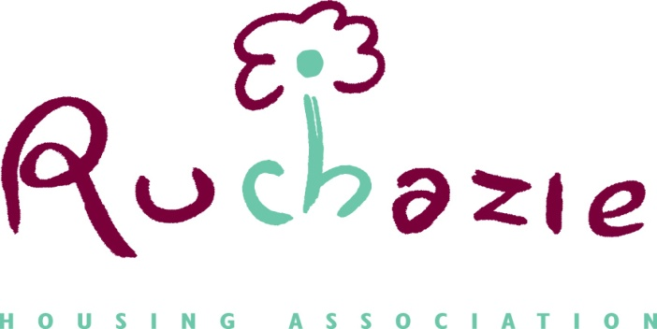

Ruchazie Housing Association
Fair Processing Notice
(How we use your personal data)

This Fair Processing Notice FPN) explains what information we collect, when we collect it and how we use this. During the course of our activities we will process personal data (which may be held on paper, electronically, or otherwise) about you and we recognise the need to treat it in an appropriate and lawful manner. The purpose of this notice is to make you aware of how we will handle your information. This FPN covers housing applicants, tenants and customers, visitors to our website and premises, members of the association, job applicants and contractors/suppliers. Separate FPNs are available for employees and governing body members.

Who are we?
Ruchazie Housing Association Ltd is a Scottish Charity (Scottish Charity Number SCO41911) and having their Registered Office at 24 Avondale Street, Glasgow G33 3QS. We take the issue of security and data protection very seriously and strictly adhere to the laws/regulations published in the Data Protection Act 2018 and the UK General Data Protection Regulation, together with any domestic laws subsequently enacted.

We are notified as a Data Controller with the Office of the Information Commissioner under registration number Z7471848 and we are the data controller of any personal data that you provide to us.

Ruchazie Housing Association has appointed RGDP LLP to be their DPO:

RGDP LLP
Level 2
One Edinburgh Quay
133 Fountainbridge
Edinburgh
EH3 9QG

info@rgdp.co.uk
0131 222 3239 / 07741738842

Any questions relating to this notice and our privacy practices should be sent to Janice Shields, Director, Ruchazie Housing Association, 24 Avondale Street, Glasgow G33 3QS.

How we collect information from you and what information we collect
We collect information about you:
- when you apply for housing with us, become a tenant, request services/ repairs, enter into a factoring agreement with ourselves or otherwise provide us with your personal details;
- when you apply to become a member;
- when you visit our website;

- from your use of our online services, whether to report any tenancy/ factor related issues, make a complaint or otherwise;
- from your arrangements to make payment to us (such as bank details, payment card numbers, employment details, benefit entitlement and any other income and expenditure related information);

- when you apply for a job at Ruchazie Housing Association;

- when you supply services to us and/or you are a contractor with us.
We collect the following information about you and your household
- name;  - address;  - telephone number;  - e-mail address;  - gender;  - ethnicity;  - Medical/health related information | - any details of disability;  - national Insurance number;  - next of kin/emergency contact;  - bank details;  - employer/employment details;  - income details;  - Passport/driving licence details

We receive the following information from third parties:
- Benefits information, including awards of Housing Benefit/ Universal Credit  - Payments made by you to us, via allpay, bank transfer or any other method  - Reports as to the conduct or condition of your tenancy, including references from previous tenancies, and complaints of anti-social behaviour | - Complaints or other communications regarding behaviour or other alleged breaches of the terms of your contract with us, including information obtained from Police Scotland;  - Information supplied by the relevant local council with regards to a homeless application.
Why we need this information about you, how it will be used and the legal bases for processing
- to enter into a contract with you and undertake and perform our obligations and duties to you in accordance with the terms of our contract with you  - to enable us to supply you with the services and information which you have requested;  - to enable us to respond to your repair request, housing application and complaints made | - to analyse the information we collect so that we can administer, support and improve and develop our business and the services we offer;  - to contact you in order to send you details of any changes to our or supplies which may affect you;  - for all other purposes consistent with the proper performance of our operations and business; and  - to contact you for your views on our products and services.

Sharing of Your Information
The information you provide to us will be treated by us as confidential. We may disclose your information to other third parties who act for us for the purposes set out in this notice or for purposes approved by you, including the following:
- If we enter into a joint venture with or merge with another business entity, your information may be disclosed to our new business partners or owners;
- If we instruct repair or maintenance works, your information may be disclosed to any contractor;
- If we are investigating a complaint, information may be disclosed to Police Scotland, Local Authority departments, Scottish Fire & Rescue Service and others involved in any complaint, whether investigating the complaint or otherwise;
- If we are updating tenancy details, your information may be disclosed to third parties (such as utility companies and Local Authority);
- If we are investigating payments made or otherwise, your information may be disclosed to payment processors, Local Authority and the Department of Work & Pensions;
- If we are conducting a survey of our products and/ or service, your information may be disclosed to third parties assisting in the compilation and analysis of the survey results
Unless required to do so by law, we will not otherwise share, sell or distribute any of the information you provide to us without your consent.
- Transfers outside the UK and Europe
Your information will only be stored within the UK and EEA.

Security

We have implemented appropriate technical and organisational measures in order to prevent your personal data from being accidentally or unlawfully accessed, altered, lost, destroyed or otherwise used in an unlawful manner. When you give us information, we take steps to make sure that your personal information is kept secure and safe. All information is stored in a secure file or scanned onto our system where a password is required to access that information. You can obtain a copy of our Data Protection Policy from our website or by contacting our office.

How long we will keep your information

We review our data retention periods regularly and will only hold your personal data for as long as is necessary for the relevant activity, required by law, or as set out in any relevant contract we have with you.

Your Rights

You have rights in relation to your personal data and can ask:

- ask for a copy of the information about you held by us in our records;
- require us to correct any inaccuracies in your information;
- make a request to us to delete what personal data of your we hold; and
- object to receiving any marketing communications from us.

If you would like to exercise any of these rights, please contact us at gdpr@ruchazieha.co.uk
You also have the right to complain to the Information Commissioner’s Office in relation to our use of your information. The Information Commissioner’s Office contact details are below:
The Information Commissioner’s Office
Wycliffe House
Water Lane
Wilmslow
Cheshire
SK9 5AF

www.ico.org.uk
0303 123 1113

The accuracy of your information is important to us - please help us keep our records updated by informing us of any changes to your email address and other contact details.

Ruchazie Housing Association, 24 Avondale Street , Ruchazie, Glasgow, G33 3QS
Tel: 0141 774 4433 Email: gdpr@ruchazieha.co.uk
www.ruchazieha.co.uk

