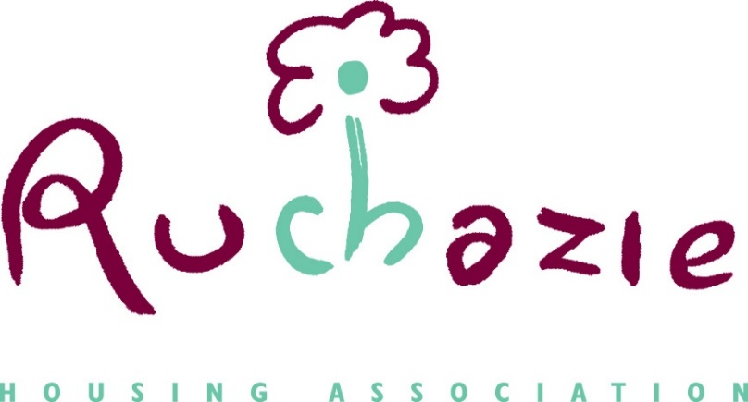

DONATIONS POLICY

Date of Policy | January 2020
Date approved by Management Committee | January 2020
Amendment to Para 3.5 | February 2022
Date for review | January 2023

1. Scope
1.1 Ruchazie Housing Association’s (RHA’s) Rules require that “The Committee shall set and review periodically its policy for the donation of funds to charities” (79.2). Such donations must further the objects of RHA, and the management committee must report to the shareholding members of RHA on such donations as are made. This policy meets the requirements of the Rules.
1.2 This policy is in two parts. Firstly, donations that can be made to charities which are in furtherance of RHA’s objects, particularly as set out in paragraph 2.2 of the Rules: “any other purpose or object permitted under Section 24 of the Housing (Scotland) Act 2010 which is charitable both for the purposes of Section 7 of the Charities and Trustee Investment (Scotland) Act 2005 and also in relation to the application of the Taxes Acts”.
1.3 Secondly, a Small Grants Fund will be provided for in the annual budget, providing for small amounts to be donated to other local organisations, which also advance RHA’s wider role objectives.
1.4 Details of any donations made from year to year under this policy will be provided in RHA’s annual report, a copy of which will be provided to each member of the association.
1.5 All matters relating to the receiving of gifts and hospitality by staff and management committee members, including gifts and hospitality provided by RHA, and seeking donations from contractors or suppliers when fundraising for charity or for prizes at our community events, and any individual provision of payments and benefits to tenants, are dealt with in RHA’s Entitlements, Payments and Benefits Policy, and associated guidance.
2. Donations to charities
2.1 RHA is permitted to make donations to charities which are in furtherance of its objects. All such donations must be provided for within the approved budget for the year. Where any such donation in excess of £500 per individual donation is proposed, or where more than one donation is to be made to the same organisation in the same year, constituting an aggregate sum in excess of £500, then either specific and named provision should be made in the annual budget, or else separate approval to make this donation must be obtained from the management committee, prior to making the donation. Such donations can be made subject to conditions, including the provision of reports on outcomes benefitting RHA tenants and the Ruchazie area, where considered appropriate by the management committee.
2.2 The Director has delegated authority to make payments to charities in accordance with this policy of less than £500, but must report to the next following meeting of the management committee any donation made under these delegated powers, including an explanation of how it complies with the policy’s requirements. Prior to any such payments being made, the Director will check that the proposed recipients are registered charities, and there is sufficient similarity between the charitable purposes of RHA and the proposed recipient.
3. Small Grants Fund
3.1 A Small Grants Fund has been established by RHA to enable it to make small donations to local groups who are not charities, for specific purposes or events which support its wider role objectives
3.2 This fund will be financed from RHA’s commercial premises income, and not from rental income from its social housing tenancies.
3.3 Any recipient of a donation from the fund must be non-profit making, non-party political, and locally based. The fund will not support religious or pressure groups.
3.4 Payments from the fund will not exceed £2,500 in any one year, and must be included and approved as part of the annual budget process.
3.5 Only one donation will be given to an organisation in any one year. The maximum that can be given to any organisation in one year is £500.
3.6 The Director has delegated authority to arrange for the distribution of any amounts donated under this fund, in accordance with the requirements of the policy, and will report back to the management committee on donations made from time to time.
4. Bequests and substantial donations
4.1 RHA may accept money, property, etc. that is bequeathed to it, to be applied in accordance with its objects, aims and objectives. It may also accept donations from individuals or organisations who wish to support its work and activities.
4.2 RHA will seek to respect the wishes of any benefactors as to how such funds are applied, subject to these being within the association’s objects and purposes, and current aims and objectives.
5. Reporting and review
5.1 All donations made within the terms of this policy during any given year will be reported to the management committee in a form that can then be incorporated into the Annual Report of the association’s work for the year.
5.2 This report will include details of names and amounts paid to all, with additional details provided for any amounts over £1000.
5.3 This policy will be reviewed by January 2023, or sooner if circumstances should require it.

