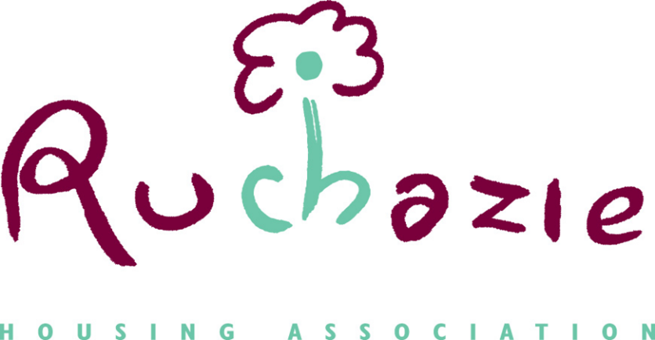

COMPLAINTS REPORTING
Adopted from SPSO
April 2021

Contents
Roles and responsibilities 3
Recording, reporting, learning from and publicising complaints 6
Recording complaints 6
Learning from complaints 7
Reporting of complaints 7
Publicising complaints information 8

Roles and responsibilities
- All staff will be aware of:
- the Complaints Handling Procedure (CHP)
- how to handle and record complaints at the frontline response stage
- who they can refer a complaint to, in case they are not able to handle the matter
- the need to try and resolve complaints early and as close to the point of service delivery as possible; and
- their clear authority to attempt to resolve any complaints they may be called upon to deal with.
- Training on this procedure will be part of the induction process for all new staff. Refresher training will be provided for current staff on a regular basis.
- Senior management will ensure that:
- Ruchazie Housing Association’s (RHA) final position on a complaint investigation is signed off by an appropriate manager or officer in order to provide assurance that this is the definitive response of RHA and that the complainant’s concerns have been taken seriously
- it maintains overall responsibility and accountability for the management and governance of complaints handling (including complaints about contracted services)
- it has an active role in, and understanding of, the CHP (although not necessarily involved in the decision-making process of complaint handling)
- mechanisms are in place to ensure a consistent approach to the way complaints handling information is managed, monitored, reviewed and reported at all levels in [the organisation]; and
- complaints information is used to improve services, and this is evident from regular publications.
- Management Committee As the governing body with responsibility for overseeing our work, our management committee provides leadership and strategic guidance. It also ensures compliance with our policies and procedures. In relation to complaints, its role is threefold:
- to approve the adoption of the CHP
- to ensure that staff keep to this CHP and associated internal processes (through involvement with senior management or directly)
- to ensure that information and learning from complaints are used to improve our understanding of, and to steer, our policies and practices.
- Particularly important is the management committee's role in developing and fostering a culture that values complaints. The management committee must ensure that recording and reporting of complaints is thorough and effective, so that reports to committee reflect a true picture of all complaints.
- A management committee that values complaints will:
- support all staff in handling complaints locally, quickly and effectively, to reduce the potential for a complaint to escalate
- encourage frontline staff to be 'active listeners' and to understand and act on the information they receive
- set out how complaints data will be reported and used to promote continual improvement
- ensure that tenants and other customers are kept informed about how we have used feedback to improve services.]
- Director: The Director provides leadership and direction in ways that guide and enable us to perform effectively across all services. The Director will ensure that all new staff receive appropriate training and current staff receive refresher training.
This includes ensuring that there is an effective CHP, with a robust investigation process that demonstrates how we learn from the complaints we receive. The chief executive may take a personal interest in all or some complaints, or may delegate responsibility for the CHP to senior staff. Regular management reports assure the chief executive of the quality of complaints performance.
- The Director is also responsible for ensuring that there are governance and accountability arrangements in place in relation to complaints about contractors. This includes:
- ensuring performance monitoring for complaints is a feature of the service/management agreements between [the organisation] and contractors
- setting clear objectives in relation to this complaints procedure and putting appropriate monitoring systems in place to provide [the organisation] with an overview of how the contractor is meeting its objectives
- Senior Officers: On the chief executive’s behalf, senior managers may be responsible for:
- managing complaints and the way we learn from them
- overseeing the implementation of actions required as a result of a complaint
- investigating complaints; and
- deputising for the chief executive on occasion.
- They may also be responsible for preparing and signing off decisions for customers, so they should be satisfied that the investigation is complete and their response addresses all aspects of the complaint. However, senior officers may decide to delegate some elements of complaints handling (such as investigations and the drafting of response letters) to other senior staff. Where this happens, senior officer should retain ownership and accountability for the management and reporting of complaints.
- Complaints investigator: The complaints investigator is responsible and accountable for the management of the investigation. They may work in a service delivery team or as part of a centralised customer service team, and will be involved in the investigation and in coordinating all aspects of the response to the customer. This may include preparing a comprehensive written report, including details of any procedural changes in service delivery and identifying wider opportunities for learning across the organisation.
Recording, reporting, learning from and publicising complaints
- Complaints provide valuable customer feedback. One of the aims of the CHP is to identify opportunities to improve services across RHA. By recording and analysing complaints data, we can identify and address the causes of complaints and, where appropriate, identify training opportunities and introduce service improvements.
- We also have arrangements in place to ensure complaints about contractors are recorded, reported on and publicised in line with this CHP.
Recording complaints
- It is important to record suitable data to enable us to fully investigate and respond to the complaint, as well as using our complaint information to track themes and trends. As a minimum, we should record:
- the customer's name and contact details
- the date the complaint was received
- the nature of the complaint
- the service the complaint refers to
- staff member responsible for handling the complaint
- action taken and outcome at frontline response stage
- date the complaint was closed at the frontline response stage
- date the investigation stage was initiated (if applicable)
- action taken and outcome at investigation stage (if applicable)
- date the complaint was closed at the investigation stage (if applicable); and
- the underlying cause of the complaint and any remedial action taken.
- RHA will also keep a record of any SPSO investigation
- If the customer does not want to provide any of this information, we will reassure them that it will be managed appropriately, and record what we can.
- Individual complaint files will be stored in line with our document retention policy, which can be found on our website at www.ruchazieha.co.uk.
- Further information on how to complain can be found here S COMPLIMENTS & COMPLAINTS (ruchazieha.co.uk)
Learning from complaints
- We must have clear systems in place to act on issues identified in complaints. As a minimum, we must:
- seek to identify the root cause of complaints
- take action to reduce the risk of recurrence; and
- systematically review complaints performance reports to improve service delivery.
- Learning may be identified from individual complaints (regardless of whether the complaint is upheld or not) and from analysis of complaints data.
- Where we have identified the need for service improvement in response to an individual complaint, we will take appropriate action.
- We will provide the complainant with the information on the person who is dealing with your complaint
- We will tell the complainant we will respond to your complaint
- We will advise of any action that has been taken and when this action will be completed
- We will monitor any changes to our service as a result of a complaint
- where appropriate, performance in the service area should be monitored to ensure that the issue has been resolved; and
- any learning points should be shared with relevant staff.
- SPSO has guidance on Learning from complaints.
- The Director and Management Committee will review the information reported on complaints regularly to ensure that any trends or wider issues which may not be obvious from individual complaints are quickly identified and addressed. Where we identify the need for service improvement, we will take appropriate action (as set out above). Where appropriate, performance in the service area should be monitored to ensure that the issue has been resolved.
Reporting of complaints
- We have a process for the internal reporting of complaints information, including analysis of complaints trends. Regularly reporting the analysis of complaints information helps to inform management of where services need to improve.
- We will report at least quarterly to the Management Committee as part of our Key performance Indicator review :
- performance statistics, in line with the complaints performance indicators published by SPSO
- analysis of the trends and outcomes of complaints (this should include highlighting where there are areas where few or no complaints are received, which may indicate either good practice or that there are barriers to complaining in that area).
Publicising complaints information
- We publish on a quarterly basis in our quarterly newsletter, which will be available on our website information on complaints outcomes and actions taken to improve services. This demonstrates the improvements resulting from complaints and shows that complaints can help to improve our services. It also helps ensure transparency in our complaints handling service and will help to show our customers that we value their complaints.
- We will publish an annual complaints performance report on our website in line with SPSO requirements, and provide this to the SPSO on request. This summarises and builds on the quarterly reports we have produced about our services. It includes:
- performance statistics, in line with the complaints performance indicators published by the SPSO; and
- complaint trends and the actions that have been or will be taken to improve services as a result.
- These reports must be easily accessible to members of the public and available in alternative formats as requested.

