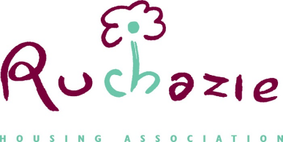
RUCHAZIE HOUSING ASSOCIATION
MANAGEMENT COMMITTEE MEETING
Thursday 22nd January 2026 @6pm
Hybrid Meeting
Zoom meeting details Meeting ID: 826 476 0943 Passcode: 123456

Item | Title | For
1. | Welcome and Apologies
2. | Minutes of meetings held  - 30th October 2025 | Approval
3. | Minutes of Audit & Risk Held on 13th November 2025
4. | Draft Budget 2026/2027
5. | Rent Consultation  - Proposal  - Communication
6. | Policy Review  - Review timetable  - Adaptations Policy  - Donations Policy
7. | Directors report
8. | Notifiable events
9. | Health & Safety
10. | Date of next meeting  Thursday 22nd January 2026

