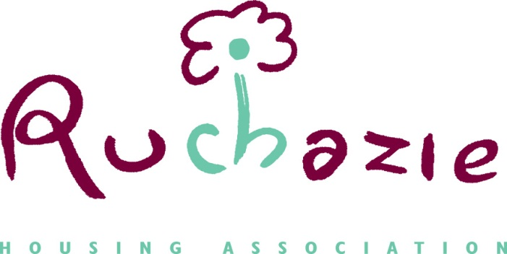

PROPERTY ACQUISITIONS POLICY

Date of Policy | March 2024
Approved by Management Committee | 28 March 2024
Date for Review | March 2027

- Policy Objectives

1.1 Ruchazie Housing Association (RHA) is committed to providing affordable, high quality and secure homes and making best use of its assets.

1.2 RHA will work with Glasgow City Council’s as part of the Glasgow Affordable Housing Supply Programme.

1.3 This policy provides a framework for property acquisition decisions from 2024-25 to 2027-28, to ensure that acquisitions are dealt with effectively and to the benefit of RHA and its existing tenants and community. This policy relates to the acquisition of available properties and does not relate to land acquisitions.
1.4 If another opportunity is presented to purchase multiple properties such as off the shelf from a private developer we would consider this under this policy.

- General Principles
2.1 Property should only be acquired where the acquisition is deemed financially viable after all due diligence is carried out, including the production of a Net Present Value calculation (NPV) and receipt of a Home Report that does not highlight any major concerns.
2.2 Any acquisition must address need within the Ruchazie community in line with corporate objectives, whether these are economic, social or environmental.
2.3 Any opportunities that arise to acquire assets alongside strategic and private sector partners will be considered and assessed on their individual merit.

- Acquisitions
3.1 RHA should only consider acquiring property where:
- It will enable RHA to deliver its corporate objectives
- It will contribute to the provision of affordable social housing in Ruchazie
- It will deliver economic and/or social development benefits
- It will provide sound financial investment, including having a positive
impact on the existing Business Plan

  - Properties will predominantly be acquired to deliver Glasgow City Council’s Affordable Housing Supply Programme (AHSP). Acquisitions may, however, be used in other instances, such as to support wider Scottish Government initiatives (e.g. Mortgage to Rent).

  - Assessment criteria will be applied when deciding to acquire an individual property as part of the AHSP. A framework of assessment criteria has been put in place to guide and determine which opportunities are pursued. The key elements that make up the framework are detailed in the table below:

Assessment Area | Question | Guiding Criteria
Location | Is the property in the right location? | - Within the Ruchazie area  - Close to concentrations of existing stock  - An area where property/land is lower value but in demand  - An area identified on the waiting list as in demand
Property type | Is it the right type of property? | - Is there demand for the property type on the waiting list  - Is there an under supply of that property type in Ruchazie and a known need  - Will the property provide alternative accommodation for a specific community group?  - Is the property of a tenure that RHA may particularly benefit from acquiring- RHA preference is social rent.
Wider benefits | Does it contribute to wider objectives? | - Support sustainable neighbourhoods and place shaping  - Remove a property blight in the neighbourhood  - Provide more suitable accommodation for priority groups/needs.  - Support a wider partner strategy such as Empty Homes Initiative, Mortgage to Rent etc  - Help to address issues of under occupation/ welfare reform  - Provide shared housing options for young people/ those affected by welfare benefit changes.
Stock Condition | Is the property condition satisfactory? | - Free from significant defects and able to be let within REASONABLE TIME SCALES IN LINE WITH RHA POLICY  - Acceptable Home Report received  - RHA inspection does not highlight any major concerns or significant expenditure is required to bring the property up to SHQS
Financial value | Does the financial assessment evidence value for money? | - Does the NPV confirm the acquisition makes a positive impact on the existing Business Plan. The NPV would also take account of a Life Cycle Costing produced for the acquisition.
Budget | Is it over the approved cost threshold? (Threshold up to Home report Value only for grant funding) | - Grant funding is only available up to valuation as per the home report

  - To be considered a viable purchase, each acquisition will be considered in its own merits, taking account of the points highlighted within the table above. This would include a report to the Management Committee detailing the results of all due diligence checks, including in relation to the condition of the property, and how it will meet housing need and benefit the Business Plan.

4. Policy Monitoring and Review
4.1 The policy will be reviewed every three years or in line with any changes to the Affordable Housing Supply Programme as part of Glasgow City Council’s Strategy.

