RUCHAZIE HOUSING ASSOCIATION 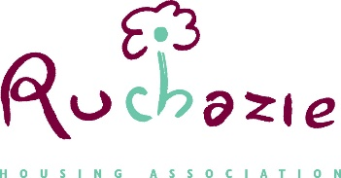
MANAGEMENT COMMITTEE MEETING
Thursday 27th June 2024
Hybrid meeting details Meeting ID: 896 9928 6761
Passcode: 653296

Item | Title
 | Welcome- Chairperson
1. | Apologies and Declaration of Interests
2. | Minutes of meeting held on 30th May 2024  Minutes of Finance & Audit Committee held on 16th May 2024 | For approval
3. | Governance  - Assurance Statement Timetable  - Annual Review of Committee effectiveness | For approval
4. | Annual Risk Review | Discussion
5. | Business Plan – Planning | Discussion and approval
6. | Policy Review | Discussion and approval
7. | Directors report | Discussion and approval
8. | AOB
9. | Date of next meeting Thursday 29th August 2024 6pm  Hybrid

